Kindly Keep it Covered
The Cast in order of Appearance:
Roland.............................. Mark Austin
Hooper.............................. Derek Kearey
Julia.................................. Anne Maynard
Olivia............................. Jeanie Ellis
Vanessa........................ . Shelly Seager
Sidney............................. ..Tom Martin
Police Sergeant Campbell..Bill Walsh

Producer/Director.................. Jane Hilliard

Kindly Keep it Covered - by Dave Freeman

Produced by West Moors Drama in November 2010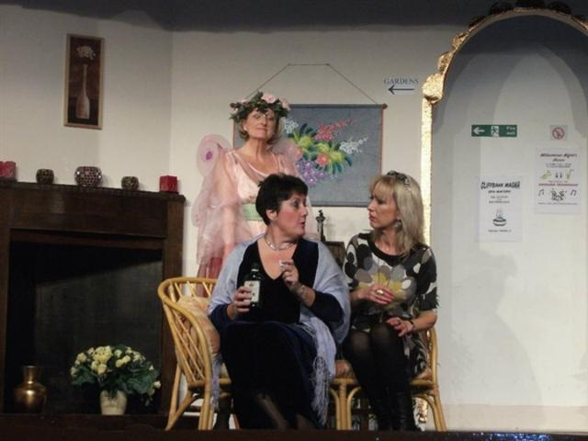

Synopsis:
Roland Dickerby, formerly of the Kindly Mutual Insurance Co., runs a health farm with his wife Julia, bought with the proceeds of a hefty insurance payout on the demiseof Julia's first husband, the charming rogue, Sidney. Life isn't easy for Roland: a healthy lifestyle is not exactly his cup of carrot juice. His formidable mother-in-law Olivia keeps a very beady eye on him and he is constantly harassed by portly guests manically in search of carbohydrates of the sweet variety. But today fate has something extra special in store for Roland. Sidney has decided to resurrect himself and turns up at the farm, just as Vanessa, the wife of Roland's ex-boss from the Kindly Mutual, checks in for a health giving visit. The action takes place in the Reception Area of a country health spa.


