Moonshine
an impossible comedy in three acts
by
John Coates

Performed by West Moors Drama Society - 25 - 27 April 1963

Cast

Michael.........................................................Derek Collins
Anne..............................................................Pat Driscoll
Charles.........................................................Leslie Saunders
Crystal.......................................................... Linsay Ward
Bill..................................................................David White
Mary...............................................................Pamela White
Aunt Daisy.....................................................Beryl Bartter
Lucy...............................................................Joy Behennah

Producer....................Kathleen Short

 | 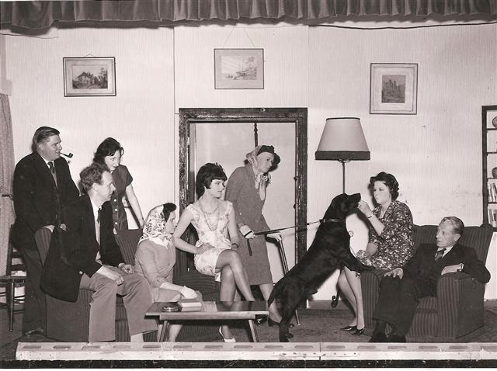 |  | 