Haywire
by Eric Chappell

Performed by West Moors Drama Society - 29 Nov - 1 Dec 2001

Cast
Alec Firth.......................................Ian Campbell
Liz................................................ Elise Scott
Maggie Firth..................................Janet Price
Phoebe Firth..................................Linda Campbell
Jamie Firth.....................................Robert Baker
Mandy Firth....................................Katy Belben

Director
Phil Bowditch

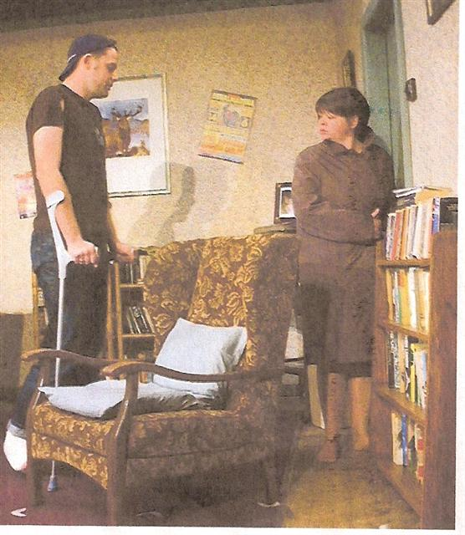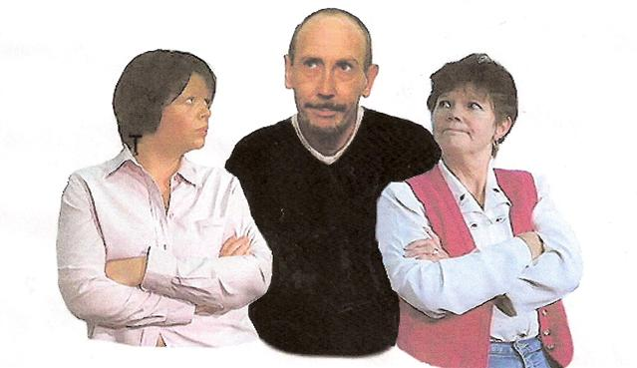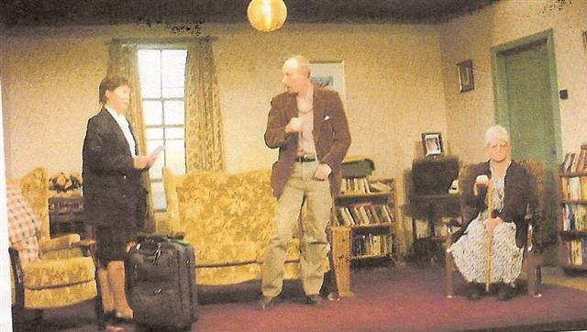
Haywire

 |  |  | 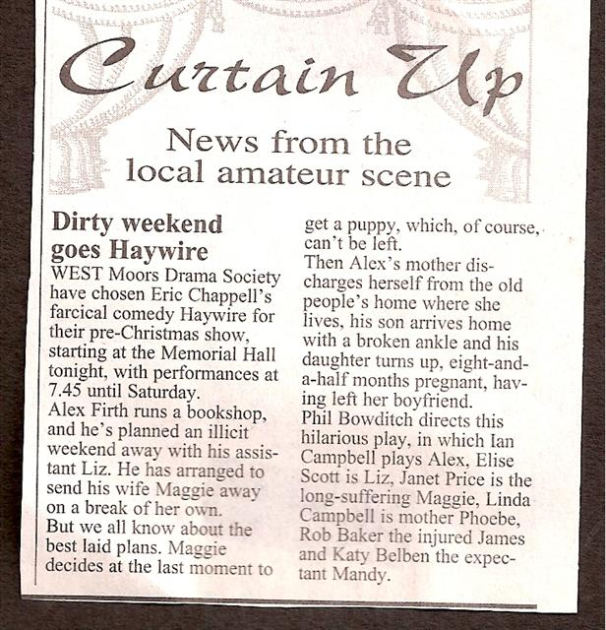  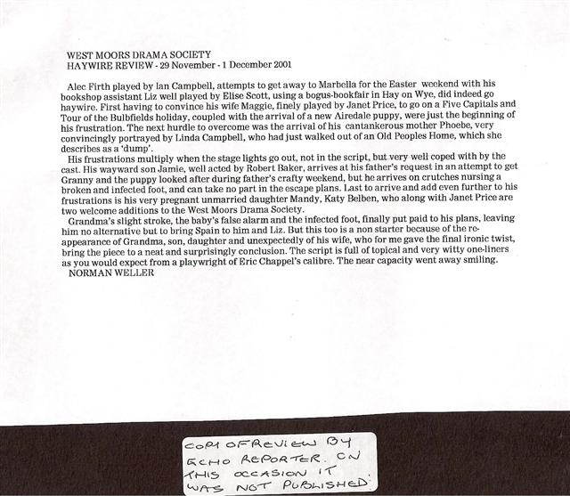
  Synopsis 