Kindly Keep It Covered
A Comedy by Dave Freeman

Performed by West Moors Drama Society 25-27 November 1999

Synopsis: Somewhere in England is an old country house converted into a modern health farm, owned by Richard Dickerby. The play is enacted in the reception area on Midsummer's Eve at 8.00pm.

Cast
Roland Dickerby.................................................. ....Mark Austin
Julia Dickerby...........................................................Lynn Seviour
Olivia........................................................................Elise Scott
Sidney......................................................................Phil Bowditch
Vanessa...................................................................Linda Campbell
Hooper.....................................................................Baird Oldrey
Campbell....................................................... ..........Emma Sargeant

Director
Rob Baker

Critique
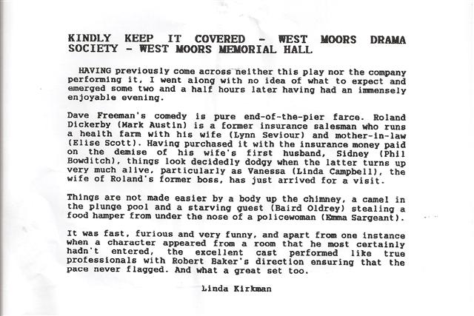

Kindly Keep it Covered 1999

