Yellow Sands
by
Eden & Adelaide Phillpots

Performed by West Moors Drama Society 22 - 24 November 1979

Cast

Richard Varwell............................................Peter Foster
Emma Major.................................................Mary Talbot
Arthur Varwell...............................................Roger Bosher
Joe Varwell...................................................George Turnbull
Thomas Major...............................................Leslie Saunders
Mary Varwell.................................................Julie Wells
Jennifer Varwell............................................Mary Mosley
Lynda Blake..................................................Margaret Walter
Minnie Masters.............................................Jane Hilliard
Nelly Masters................................................Michelle Bosher
Mr Baslow.....................................................Keith Chauncy
Ko-Ko............................................................Polly Dear

Director......................Derek Collins

 | 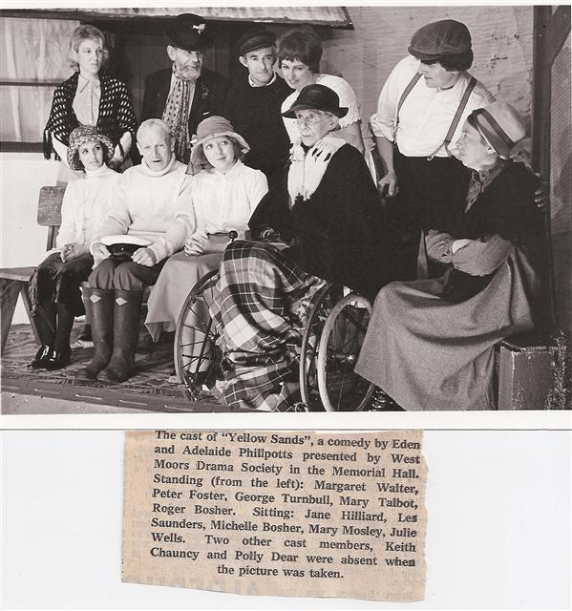 |  | 