Jack Up!
by
Ian Hornby

Performed by West Moors Drama Society 10 - 12 April 2014

Cast

Alex...........................................Tom Martin
Bobby........................................Shelly Seager
Sam...........................................Alan Dester
Les.............................................Peter Wright
Nat.............................................Derek Kearey
Pat.............................................Jeanie Ellis
Jo...............................................Anne Tillin
Chris..........................................Debbie Butterworth
Nick............................................Janet Price
Radio Voice................................Shelagh Rundle

Director..........................Jane Hilliard

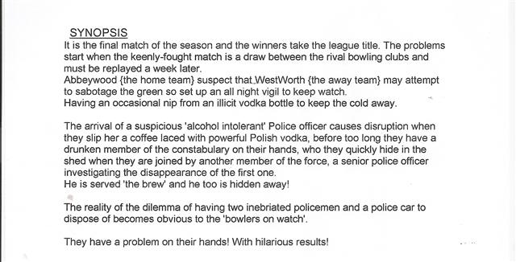

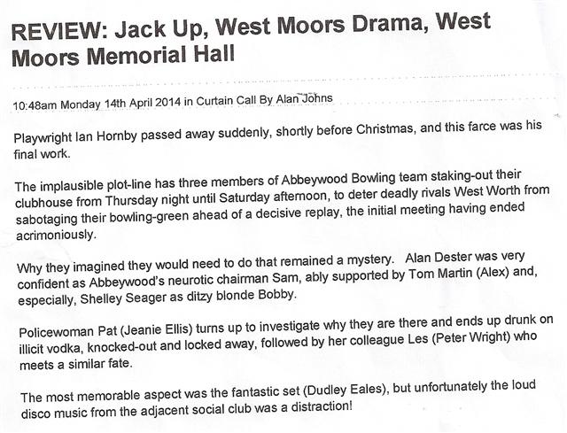
Jack Up!

