Murdered to Death
by Peter Gordon

Performed by West Moors Drama Society 20 - 22 February 2003

Murdered to Death

 | Cast  Mildred................................... ...Linda Middleton  Dorothy.................................... .Jo Hilliard  Bunting.................................... ..Albert Cook  Col. Charle Craddock............... Mark Austin  Margaret Craddock....................Jane Hilliard  Pierre Marceau.......................... Dan Sheen  Elizabeth Hartley Trumpingto..Shirley Seager  Joan Maple................................ Janet Price  Inspecto Pratt...................... ......Phil Bowditch  Constabl Thomkins...................Rob Baker  Director  Shelagh Rundle | 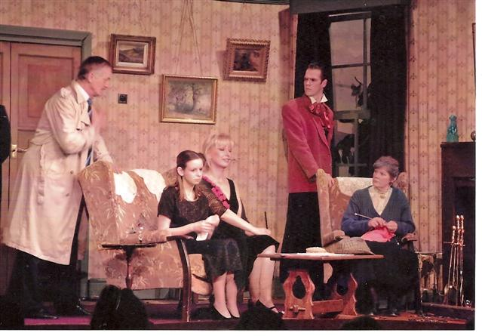

Critique
