Doctor Waring is concerned about his daughter, Shelia. She is working for a wealthy stamp dealer and has fallen in love with him. The doctor has made enquiries about the dealer, Michael Rentour and now knows that he is a very dubious person. His daughter will not listen to him so Doctor Waring goes to ... | Doctor Waring is concerned about his daughter, Shelia. She is working for a wealthy stamp dealer and has fallen in love with him. The doctor has made enquiries about the dealer, Michael Rentour and now knows that he is a very dubious person. His daughter will not listen to him so Doctor Waring goes to ...

 | 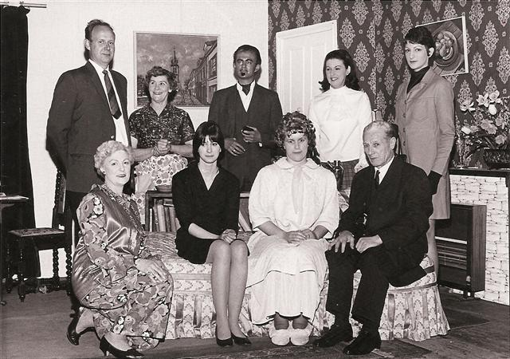 |  | 